Building an Interactive Map for the CRF

Jacob Haley, Russell Chebahtah,

& Vanessa Bauer

Saint Martin’s University

**Introduction**

The goal of this project was to integrate interactive maps onto the Coral Restoration Foundation’s website through the use of R. The Coral Restoration Foundation is the largest coral reef restoration organization in the world. It was founded in response to the widespread loss of the dominant coral species on the Florida Reef Tract, and it is headquartered in Key Largo, Florida.

**Implementation and Challenges**

In the beginning, the objective was to create a visualization to represent the coral reef foundation’s progress and add it to their website. The visualization was to be created through the use of ShinyApp in RStudio and to have it be an interactive map on a hosted server. Inevitably, however, some challenges had emerged. First, there was difficulty establishing how the CRF would actually implement the ShinyApp onto their website. The CRF also needed to provide our team with a large enough data to actually accomplish anything. Another issue was we needed to determine how to actually implement visualizations of the data and merging them within a map. Finally, the client also gave our team no direction as to what they actually wanted.

**Solutions**

To resolve these issues, we decided to not use ShinyApp as it would not be possible to collaborate in time with the client to determine the logistics of server and maintenance and website access. In regards to the data, our correspondent eventually sent us a much larger dataset that was fit for implementation. We also explicitly asked them what they were seeking in terms of results. This led us to the creation of a map with every reef site plotted using the provided data. In addition, we incorporated graphs that displayed the amount of corals planted relative to other sites. The colors in the graphs display the genetic diversity of reefs.

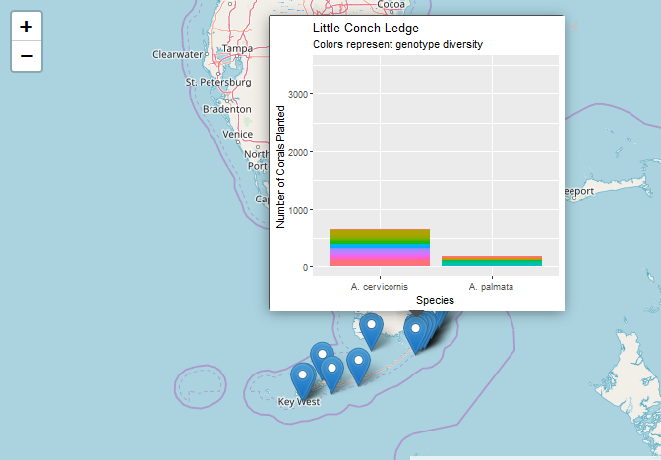

*Figure 1:* The map of the data set with plotted points of reefs and embedded graphs showing genetic diversity.

**Conclusion**

Overall, the client was satisfied with the results of this project. However, looking forward, it would be ideal to implement automatic updates for the map. ShinyApp implementation could also improve the design in addition to adding more intricate visualizations.

This project was challenging and required us to learn about embedded data visualizations. Additionally, it introduced us to the frustrations and challenges associated with working with a client. It also taught us more about the project lifecycle involved with creating a product.